Personal Details
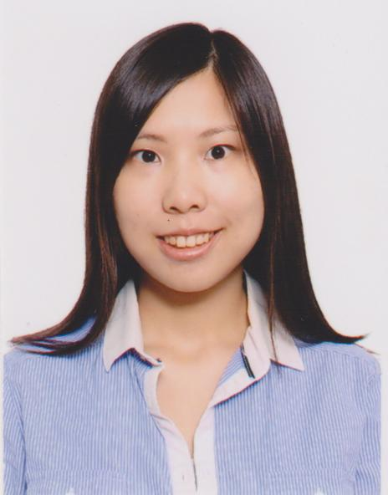
Name: | Yan Shuk Man, Candace 殷淑敏
Date of Birth: | 13 June 1987 (Single)
Gender: | Female
Telephone no.: | 6236 0368
Email address: | yan_man613@hotmail.com
Able to: | Travel overseas

Personal Strength
I am a confident person with a very out-going and friendly personality. I am patient and show initiative in facing challenges. I have great communication skills and able to work with different kinds of people. As a trustworthy and honest person, it helps me to survive under different working environments.
Education Background

2007 – 2009 | Macquarie University, Sydney, Australia  Bachelor of Commerce(Faculty of Business and Economics) –  Major in Accounting
2006 – 2007 | The Sydney Institute of Business and Technology, Sydney, Australia  Diploma of Commerce
1999 – 2006 | YLPMSAA Tang Siu Tong Secondary School

Qualification

2010 – present | A Qualified member of CPA Australia
2010 | International English Language Testing System (IELTS) – Band Score 7
2006 | LCC& I Accounting Level 2, passed with Credit

Working Experience
April 2015 –  Oct 2016 |  | China Development Bank Corporation HK Branch  As a Senior Officer  Reason for Leaving: Seek for better job opportunity in Singapore.
  Nature: | Banking
  Duties: | - Responsible to make payments  - Responsible to handle reimbursements  - Responsible to prepare bank reconciliations  - Responsible to handle month end and year end closing  - Liaise with external parties  - Assist in ad hoc assignment
Aug 2013 –  May 2015 | Cherish Learning Centre  As an Owner and tutor  Reason for Leaving: My business partner immigrates to UK and rental increases.
  Nature: | Tutorial Centre
  Duties: | - Responsible to promote courses  - Teaching kids (Playgroup and primary students)  - Handle administrative works  - Assist in ad hoc assignment
Dec 2012 –  ar 2013 | Moelis & Company Asia Limited  As a Junior Accountant (3 months contract)  Reason for Leaving: End of contract
  Nature: | An investment bank
  Duties: | - Responsible to prepare monthly reports  - Responsible to maintain compliance records  - Responsible to reimbursements  - Responsible to issue invoices and cheques  - Liaise with external auditors  - Assist in ad hoc assignments
May 2010 –  Apr 2012 | Heng & Tan CPA  As a Junior Accountant  Reason for Leaving: Seek for better career development
  Nature: | CPA firm
  Duties: | - Responsible to prepare detailed audit report  - Responsible to review accounts of taxpayers and also conduct on-site audits  - Responsible to inspect the account books of a company for analyzing thtransactions and efficiency  - Responsible to evaluate the finance of a taxpayer to find out tax  liability  - Assist in ad hoc assignments

Activities and Services

2006 | Committee of Student Union
2001 | Member of Hong Kong Youth Award Scheme
2000 | Committee of English Drama Club

Skills

Languages: | Fluent in English, Cantonese and Mandarin.
Computer Skills: | MS Word, Excel, PowerPoint, Outlook
Typing Skills: | Typing Skills: English 40 w/m, Chinese 30 w/m
Others: | Oracle, Quickbook, MYOB, Hong Kong Driving License

Availability: | Immediately available
Expected Salary: | Negotiable
Remarks: | According to the comments of my previous employers, I am proved to be work hard  and eager to learn. I'm always gentle and friendly. I'm able to foster relationships with seniors and clients. I am a good team player with the ability to work independently.  Being an owner, I have learned how to solve difficulties independently and efficiently. I understand what my boss is looking for and try to achieve tasks with the best interest of my company. I am looking for an opportunity to further develop my career in education field.

